*Powerenjoy*

Test Plan

Version *<0.01>*

*<31/12/2016>*

1. Introduction
   1. Revision History
   2. Purpose and Scope
   3. List of Definitions and Abbreviations
   4. List of Reference Documents
2. Integration Strategy
   1. Entry Criteria
   2. Elements to be Integrated
   3. Integration Testing Strategy
   4. Sequence of Component / Function Integration **struttura dipende dalla 2.3
      1. Software Integration Sequence
      2. Subsystem Integration Sequence
3. Individual Steps and Test Description
4. Tools and Test Equipment Required
5. Program Stubs and Test Data Required
6. Effort Spent

**1 INTRODUCTION**

**1.1 Revision History**

|  |  |  |  |  |  |
| --- | --- | --- | --- | --- | --- |
| **Version #** | **Implemented**  **By** | **Revision**  **Date** | **Approved**  **By** | **Approval**  **Date** | **Reason** |
| 0.01 | *<Author name>* | *<mm/dd/yy>* | *<name>* | *<mm/dd/yy>* | Test Plan draft |
|  |  |  |  |  |  |
|  |  |  |  |  |  |

**1.2 Purpose and Scope**

PowerEnjoys is a Car Reservation professional software whose main goal is to help people move around easier, without having to rely on their personal transport; a secondary goal is the reduction of cities’ pollution and acoustic noise.

A user can look for a car by entering either his current position (detected by using their smartphone’s GPS) or a specific location, chosen on the map, that he’ll need to reach by himself.

The system policies encourage a smarter use of our service, by offering discounts to those who share a trip together.

This is The Integration Test Plan Document (ITPD) for the PowerEnjoy (PE) Project.

The ITPD’s purpose is to document e define the approach to be used in the Integration Testing of all the project’s components.

In addition, a brief description about testing software and tools to be used will be given.

**1.2 List of Definitions and Abbreviations**

* Sono da mettere, imho, solo quelli inerenti al documento. INSERITE QUELLI CHE AVETE USATO NELLE VOSTRE PARTI, le definizioni le mettiamo dopo
* *Cost of the Trip*: raw price of the service calculated only on the base of the duration of the car’s usage, before discounts or additional charges are applied.
* *Virtuosness Coefficient*: the factor by which to multiply the cost of the trip to get the amount of the bill. Its initial value is 1.
* *Supervisor*: a company employee who work at the Car hub controller
* *Recharge on site*: a company procedure: a worker is sent to recharge a low car that was parked detached from the power grid
* *Car recovery*: a worker is sent to retrieve a car that has been forgotten outside a safe area and move that car into in one of these lot.
* *Guest*: a person who is not already registered to the system.
* *User*: a registered customer.
* *DD*: Design Document
* *DB*: DataBase
* *RASD*: Requirement Analysis and Specification Document
* *ITPD*: Integration Test Plan Document

**1.3 List of Reference Documents**

* The PowerEnjoy’s RASD
* PowerEnjoy’s DD
* The project’s Assignments PDF
* Old years projects
* The ITPD standards
* Software Engineering course slides
* Specific tools’ tutorials and documentation

**2. Integration Strategy**

**2.1. Entry Criteria**

This section describes the prerequisites that need to be met before integration testing can be started.

First of all, code inspection has to be performed on all the code in order to find possible issues and to ensure maintainability and respect of conventions.   
Taking as reference the component diagram (2.2 from DD), the following component must be unit-tested before our integration tests:

• Notifications displayer (Supervisor)  
• Sensor/actuator manager (Car)  
• Info displayer (Car)  
• Mobile App (User)  
• DB  
• Email gateway  
• Push gateway

The DB component represents the database: because the database run on the same system of the application server, in the component diagram it is represented as a simple component; following this convention, we will continue to represent it as a component and to consider it as part of the “central server” subsystem.

In addition, there are present in the diagram 2 components which represent external services (Google maps and bank service), which can be considered already reliable and do not need to be unit tested.

We should test all non-trivial methods, getter and setter methods can be skipped.

The components “User” and “Safe park slot”, which contain only getter and setter methods, are considered as already tested.

**2.2. Elements to be integrated**

The elements to be integrated are all the elements represented in the already mentioned component diagram, considering that our system must cooperate with 2 external services (google maps and the bank service).

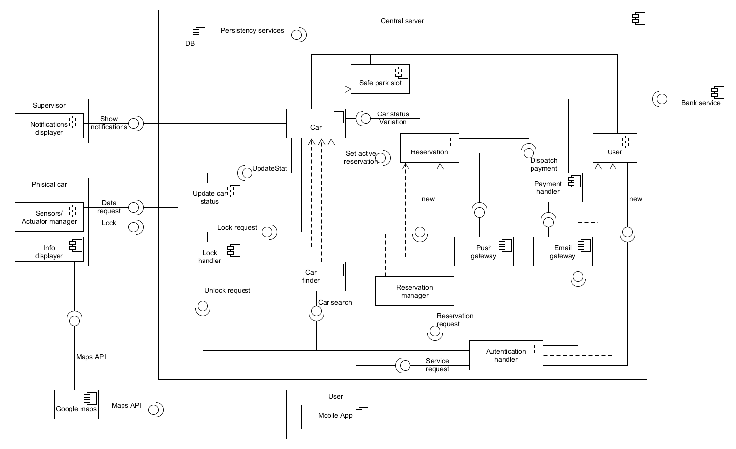

*Component diagram*

**2.3. Integration testing strategy**

The integration strategy that we decided to follow is the bottom-up approach. The main reason for this choice is that we assume that we already have the unit-test for some of the simplest components, so we can proceed from the bottom.

Moreover, except for the central server, the other high-level components are composed by simple parts that we consider as atomic; the high level components communicate through well defined interfaces (REST API), so the integration of each of them will not be hard in a later time.

In addition, this approach has other intrinsic advantages: we can limit the usage of stubs, the errors are well located and, if the realization of the components follows a bottom-up approach too, the testing of lower level modules can take place earlier.

**2.4. Sequence of component/function integration**

**2.4.1. Software integration sequence**

In this section it will be shown the sequence of the components’ integration.

As mentioned above, we consider the high-level components “User”, “Supervisor” and “Physical car” as atomic subsystems, and therefore they are not consider in this section; in the following figure we describe in detail the integration sequence of the components of the “Central server” subsystem.

The bottom-up approach has been respected in the majority of the cases, with only two exception: it’s present a circular dependency between the “Car” and “Reservation” components, that forces us to take a choice on which one we implement first, and the push gateway, which have to send information both to the physical car and to the mobile app: we will need a stub for the latter one.

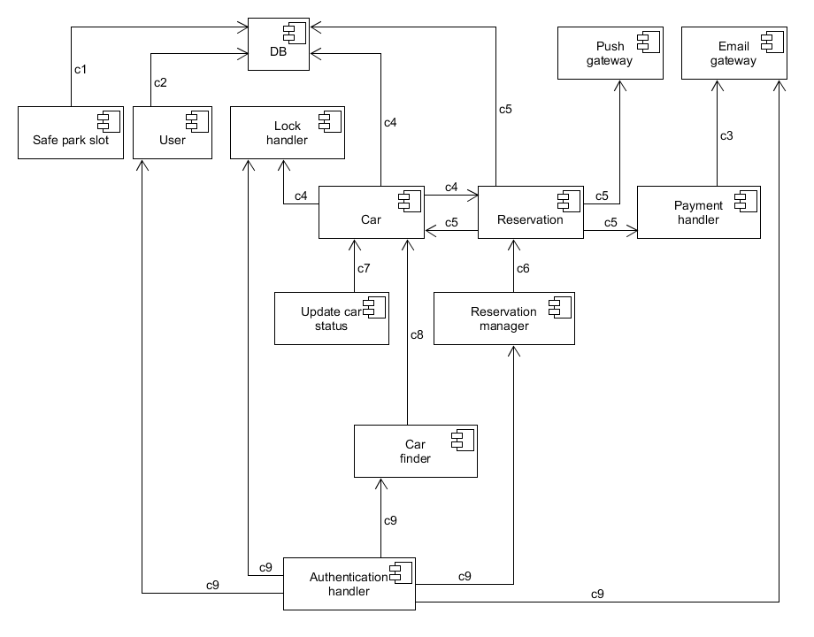

*Central server integration sequence*

|  |  |  |
| --- | --- | --- |
| N° | Component | Integrates with |
| c1 | Safe park slot | DB |
| c2 | User | DB |
| c3 | Payment handler | Email gateway |
| c4 | Car | DB, Reservation, Lock handler |
| c5 | Reservation | DB, Car, Push gateway, Payment handler |
| c6 | Reservation manager | Reservation |
| c7 | Update car status | Car |
| c8 | Car finder | Car |
| C9 | Authentication handler | User, Lock handler, Car finder,  Reservation manager, Email gateway |

**2.4.2. Subsystem integration sequence**

For subsystem integration we follow the bottom-up approach too. The reason to do so is that it’s simpler to implement driver for testing the low level components, instead of making coherent stubs of the subsystems. Moreover, a working central server is needed to test in a profitable way the mobile app (User subsystem).

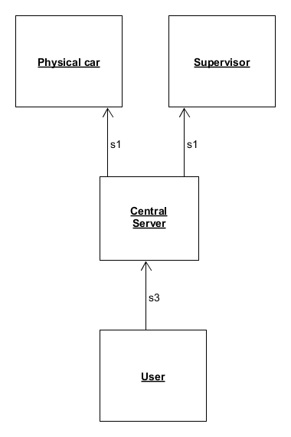

*Subsystems integration sequence*

|  |  |  |
| --- | --- | --- |
| N° | Subsystem | Integrates with |
| s1 | Central server | Physical car, Supervisor |
| s2 | User | Central server |

**3. Individual steps and test description**

**3.1 Integration test case c1**

|  |  |
| --- | --- |
| Test Case Identifier | C1T1 |
| Test Item(s) | Safe park slot -> DB |
| Input Specification | Typical queries on table Safe park slot |
| Output Specification | Correct result returned |
| Environmental Needs | DB |

Test Description: the DB should contain the corret informations related to the parking slots. Some views of known test data must be done.

**3.2 Integration test case c2**

|  |  |
| --- | --- |
| Test Case Identifier | C2T1 |
| Test Item(s) | User -> DB |
| Input Specification | Typical queries on table ~~Safe park slot~~ User |
| Output Specification | Correct result returned / correct data insertion |
| Environmental Needs | DB |

Test Description: the “new” interface of the User Component will be used to insert and modify some User data into the DB.

The tester should then verify that the DB contains the correct data.

**3.3 Integration test case c3**

|  |  |
| --- | --- |
| Test Case Identifier | C3T1 |
| Test Item(s) | Payment handler -> Email gateway |
| Input Specification | Typical payment handler input |
| Output Specification | Correct request for bank services / Correct email generation |
| Environmental Needs | Email gateway |

Test Description: some test payment will be executed.

An e-mail, sent via the Email Gateway component, is expected to be received. A test g-mail account will be used for such purpose.

Some wrong amount (like a negative value) must be tested.

**3.4 Integration test case c4**

|  |  |
| --- | --- |
| Test Case Identifier | C4T1 |
| Test Item(s) | Car -> DB |
| Input Specification | Typical queries on table Car |
| Output Specification | Correct result returned / correct data insertion |
| Environmental Needs | DB |

Some standard DB interactions.

|  |  |
| --- | --- |
| Test Case Identifier | C4T2 |
| Test Item(s) | Car -> Reservation |
| Input Specification | Typical input for “car status variation” method of reservation |
| Output Specification | Check if the correct method of reservation is called |
| Environmental Needs | Update car status driver, C1, Reservation stub |

Knowing that the ”Car status variation” interface is used to notify the reservation object about the changing of specific attributes on the state of the Associated car, a correct detection of when the first engine ignition occurs (so the system can register the number of passenger, or when a car is parked (in a safe area or not, in order to correctly launch the countdown, or ultimately, when a parked car is turned back on, in order to delete the running countdown) must occour.

Also, The ”set active reservation” method, used by a new reservation to associate itself to the reserved car, is also used by a reservation when it is about to expire, to set the ”actualReservation” attribute of the associated car to null. Both of these interactions must be tested.

|  |  |
| --- | --- |
| Test Case Identifier | C4T3 |
| Test Item(s) | Car -> Lock handler |
| Input Specification | Typical input for “Lock handler” |
| Output Specification | Check if the request is sent under the correct conditions, check if the physical car correctly locks |
| Environmental Needs | Physical car, Update car status driver, Reservation driver |

Test Description: all the different interactions between these components are to be tested (lock/unlock/timeout/remote unlocking (??)/…)

**3.5 Integration test case c5**

|  |  |
| --- | --- |
| Test Case Identifier | C5T1 |
| Test Item(s) | Reservation -> DB |
| Input Specification | Typical queries on table Reservation |
| Output Specification | Correct data insertion |
| Environmental Needs | DB |

Some views of the stored reservations’ parameters are to be generated and then cross checked with the test data.

|  |  |
| --- | --- |
| ~~Test Case Identifier~~ | ~~C5T2~~ |
| ~~Test Item(s)~~ | ~~Reservation -> Car~~ |
| ~~Input Specification~~ | ~~Typical input for “Set active reservation” method of reservation~~ |
| ~~Output Specification~~ | ~~Check if the correct method of car is called~~ |
| ~~Environmental Needs~~ | ~~Reservation manager driver, C4~~ |

**~~??? non è già fatto? Io lo leverei~~**

|  |  |
| --- | --- |
| Test Case Identifier | C5T3 |
| Test Item(s) | Reservation -> Push gateway |
| Input Specification | Typical “push gateway” input |
| Output Specification | Check if the correct data are dispatched |
| Environmental Needs | Mobile app (from user subsystem) stub, Physical car |

The ”push gateway” component is used to send information about the reservation status to the user’s app and to the car’s monitor. Some changes in the Reservation are to be forced (directly hardcoded **and then re-executed after the implementation of the Reservation Manager (OK??)** to allow such notifications to occour.

|  |  |
| --- | --- |
| Test Case Identifier | C5T4 |
| Test Item(s) | Reservation -> Payment handler |
| Input Specification | Typical “Payment handler” input |
| Output Specification | Check if the correct method of car is called |
| Environmental Needs | C3 |

**3.6 Integration test case c6**

|  |  |
| --- | --- |
| Test Case Identifier | C6T1 |
| Test Item(s) | Reservation Manager -> Reservation |
| Input Specification | Typical “Reservation manager” input |
| Output Specification | Check if a new reservation is correctly created, observing the requirements criteria |
| Environmental Needs | C4, C5 |

All the test required for such stated Output to occur; in addition, the push notification component integration should be re-tested.

**3.7 Integration test case c7**

|  |  |
| --- | --- |
| Test Case Identifier | C7T1 |
| Test Item(s) | Update car status -> Car |
| Input Specification | Typical “Update car status” input |
| Output Specification | Check if the car’s data are correctly updated |
| Environmental Needs | C4, Physical car |

**3.8 Integration test case c8**

|  |  |
| --- | --- |
| Test Case Identifier | C8T1 |
| Test Item(s) | Car finder -> Car |
| Input Specification | Typical “Car finder” input |
| Output Specification | Check if the position of the car which respects the search criteria are returned |
| Environmental Needs | C4 |

Some tests regarding the representation of such cars in the map are strongly suggested, to check if the position of the car is consistent with the real world and with the car own perceived position.

**3.9 Integration test case c9**

|  |  |
| --- | --- |
| Test Case Identifier | C9T1 |
| Test Item(s) | Authentication handler -> User, Email gateway |
| Input Specification | Typical “Authentication handler” input for the creation of a new user |
| Output Specification | Correct creation of a new user, email containing the password correctly sent |
| Environmental Needs | C2, Email gateway |

A test user has to be created: the ”authentication handler” calls the ”new” method of the component ”user”, and uses the ”email gateway” component to send the confirmation email containing the password to the new user.

All this data should be correct and a user creation can’t occur if the inpout fileds are invalid.

|  |  |
| --- | --- |
| Test Case Identifier | C9T2 |
| Test Item(s) | Authentication handler -> Lock handler |
| Input Specification | Typical “Authentication handler” input for an unlock request |
| Output Specification | Check if the physical car correctly unlocks under the right conditions |
| Environmental Needs | C4, C2 |

|  |  |
| --- | --- |
| Test Case Identifier | C9T3 |
| Test Item(s) | Authentication handler -> Car finder |
| Input Specification | Typical “Authentication handler” input for the research of a car |
| Output Specification | Check if the “car finder” method is correctly called |
| Environmental Needs | C4, C2 |

**Non mi ricordo come interagiscono sti due**

|  |  |
| --- | --- |
| Test Case Identifier | C9T4 |
| Test Item(s) | Authentication handler -> Reservation manager |
| Input Specification | Typical “Authentication handler” input for the creation of a new reservation |
| Output Specification | Check if the “Reservation manager” method is correctly called |
| Environmental Needs | C6, C2 |

**Non mi ricordo come interagiscono sti due**

**4 Tools and Test Equipment Required (da sistemare)**

The way the component interacts with the system is just as important as the work it performs. It’s then vital that every aspect of the integration procedure is tested with the right consideration and the right tools.

The tools used to automate the testing are the following:

* Apache JMEter: a load testing tool, built in Java, for analyzing and measuring performance; can be used to simulate heavy load on a server, network or object.
* Junit: it’sa framework used to write repeatable tests. Will be used in synergy with Arquillian and Mockito.
* Arquillian: it’s an integration testing framework for containers. Arquillian brings the test to the runtime so there’s not need to manage the runtime from the test.
* Mockito:Mockito provides a framework for interaction testing, supporting the scaffolding by defining stubs when needed.

Sometimes, after an integration between two components, new vulnerabilities are introduced. (Think about a new registration module replacing or augmenting a previous one. That may allow the creation of unwanted superusers through some exploit).

A short Vulnerability and then PenTest (Penetration Testing ) is so executed to check for vulnerabilities. The software and tools used will not be discussed here (Kali Linux, Sqlmap, Nexpose,…).

**5. Program stubs and test data required**

**5.1. Stubs**

Since we decided to follow a bottom-up approach, we only have 2 stubs to be developed during the test phase:

**5.1.1. Reservation Stub**

Usage: C4T2

Description: This stub is required to test the correctness of the interaction between the “Car” and the “Reservation” components.

In particular, when Car calls the “Car status variation” method, under certain conditions the reservation of the car can change status from active to expired: this cause the call of the “Set active reservation” method of car by the reservation.

**5.1.2. Mobile app stub**

Usage: C5T3

Description: This stub is required to test the correctness of the information sent through the push gateway; it is not necessary to emulate the entire mobile app, but the only functionality needed is the receipt of the pushed notifications.

**5.2. Data for tests**

We will initially populate the database with fake data regarding Cars and Safe area (including safe park slots); these are the only information strictly needed by some components before starting the test. Other information (such as users, reservations) could be inserted during the various test phases.

**6. Effort spent**

Gabriele:

27/12/16: 2h

28/12/16: 2h

29/12/16: 6h

30/12/16: 3h

Marco:

31/12/16: 2h

03/01/16: 1h

05/01/16: 45m

07/01/16: 4h